Now in react native we will make a simple form and we will take 3 or 4 input field and on the bais of the button click get there value and on the second button clear them and most important thing is that

You must have seen when we type password then dot dot comes and the actual password is hidden because of security How you will achieve that in React Native

First we take some text input and two buttons

When we click on one button then we get all the values and then will be displayed

And by clicking on second button all the data will be removed and our input field will be clear s

We need to make stated for every input

Suppose we have three text Input then we will make there input state

Because teacher want that every text input should be handled by their separate state

Is this correct way many people do it but you can handle these input values inside single state

But we will talk about it in another lesson

Because for now teacher want to tell us simple way to make a form in react native

And we will not complicate it



As we enter value in textfield and we have value in state

An we click on bitton to get the value and then print it all

And on clear button all the values will be cleared and in last you will have exercise

First what we do is make one input field

And add a placeholder in it saying that “Enter User Name”

<View>

      <Text style={{fontSize:30}}>Simple Form in React Native</Text>

<TextInput placeholder='Enter User Name'

/>

    </View>



There should be some style because it is not looking like a textfield to us

Now we add a style that in internal style

import React,{useState} from 'react';

import {Button, Text, View,StyleSheet, TextInput} from 'react-native';

import exStyles from './style'

function App() {

  const test ={

    color:'blue',

  }

  return (

    <View>

      <Text style={{fontSize:30}}>Simple Form in React Native</Text>

<TextInput placeholder='Enter User Name' style={styles.textInput}

/>

    </View>

  );

}

const styles = StyleSheet.create({

  textInput : {fontSize:18,

    color:'red',borderWidth:2,borderColor:'blue',margin:10

  }

})

export default App;

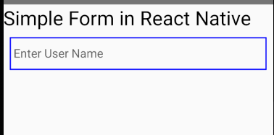

Now we need a states to handle these input fields

const [name,setName] = useState("")

const [email,setEmail] = useState("")

const [password,setPassword] = useState("")

so we declare it inside our App component

Now we add onChangeText event handler to inputText element

So that it set the respective state when something is typed in the field like name, email , password like we did previous lesson for the inputField

5:00

Now we set the value of the name attribute of the InputText component to the name state

So that we can clear it later

Now we copy the InputText and duplicate it two more times

Now make second textfield for password and email

But in their value set them to their respective state(that is state and state method made for email and password)

But in Password we are seeing the text so to replace it with dots we pass the secureTextEntry prop in password editText to true

Now our will look like below

  <View>

      <Text style={{fontSize:30}}>Simple Form in React Native</Text>

<TextInput placeholder='Enter User Name' style={styles.textInput}

onChangeText={(text)=>setName(text)} value={name}

/>

<TextInput placeholder='Enter User Name' style={styles.textInput}

onChangeText={(text)=>setPassword(text)} secureTextEntry={true} value={password}

/>

<TextInput placeholder='Enter User Name' style={styles.textInput}

onChangeText={(text)=>setEmail(text)} value={email}

/>

    </View>

Now we need some button and by the press on it we want to show details entered in the fields

And then we clear it

We add a button and give it value “print details”

Now you will say who print value from a form

We send it to API right or directly to the server side scripting language but for now we don’t have any APIs

In upcomig lessons we will integrate APIs also then we will not print anything but for now we will print the values to show that we have the data of the form

We need to change state of button (I don’t know)

Now I create another button with title Clear Details

7:55

Now we have two buttons

Bur they don’t have any space so

**Note:-**

Style does not work in buttons Teacher will tell about it later. there are properties in button to change color (maybe)

Why is this teacher will tell about it and how to apply it in separate lesson and what option to use

So we wrap out button by the View component we add margin there

So now with the marginBottom property we can increase space between them

As shown below

<View style={{marginBottom:10}}>

<Button title='Print Details'/>

</View>

<Button title='Clear Details'/>

Output is

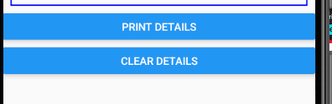

We can also set color of the button with the help of color props

<Button color = "green" title='Print Details'/>

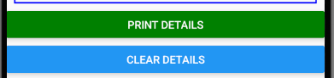

Now if we want that when we click on the print details then the state value should be shown

We create a state and call it display and bydefault set it to false

And with the help of conditional operator we show the details of the user when the user clicks on the Print details and set display to true

Code

const [display,setDisplay] = useState(false)

<View>

  {

    display?<View>

      <Text style={{fontSize:20}}>User's name is {name}</Text>

      <Text style={{fontSize:20}}>User's password is {password}</Text>

      <Text style={{fontSize:20}}>User's email is {email}</Text>

    </View>:null

  }

</View>

Output

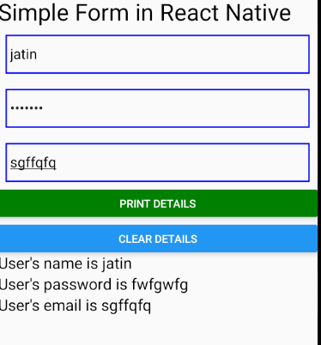

Now we want to clear the information shown here

So we can add another onpress like we did with Print details button but it will make our code very unreadable

So we create another function named as resetFormData and pass it to the onPress of the Clear details button

And there make the display set to false and other state as empty string now when you click on the clear details all the things will be clearwd

Code

const resetFormData = ()=>{

  setDisplay(false)

  setName("")

  setEmail("")

  setPassword("")

}

<Button title='Clear Details' onPress={resetFormData}/>

Now when we click on clear details then below will be shown

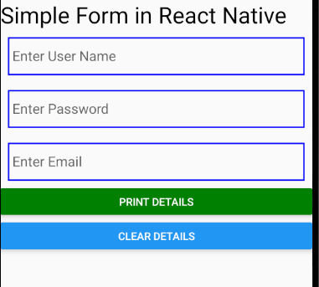

Now next step is to include validation here which we will do in upcoming part but before that tell me

You might have seen eyes option in the password field in which when you click on the eye then the password will become visible (but I will not do it because I can do it myself)

we will just manipulate the property secureTextEntry of TextInput of type password to hode or unhide property